Noise Mechanisms and Mitigation Strategies in Electrochemical MEMS Biosensors: An Innovative Review
Naren Das¹, Nidhi Sinha¹, Vipra Raj¹
¹Department of Electronics and Communication Engineering Department, Birla Institute of Technology, Ranchi, Patna Campus, Bihar,800014.
Corresponding author: e-mail address: narentitun@gmail.com

Abstract—Electrochemical MEMS biosensors have become essential tools for continuous health monitoring, environmental analysis, clinical diagnostics, and wearable systems. As sensor miniaturization advances and detection limits push into the femtomolar and single-molecule regimes, noise emerges as the dominant constraint on sensitivity, accuracy, and stability. This paper provides an innovative and forward-looking review of noise in electrochemical MEMS biosensors. Unlike traditional classifications, we present a multiscale, mechanism-centered analysis linking electrochemical reactions, micro/nanoscale device physics, MEMS structures, and CMOS readout electronics. Noise mitigation strategies are discussed across device engineering, advanced signal processing, interface chemistry, microfluidics, packaging, and AI-driven noise suppression. A roadmap for next-generation ultra-low-noise biosensing technologies is proposed.
Index Terms—MEMS biosensors, electrochemical sensing, noise mechanisms, low-noise systems, impedance spectroscopy, signal processing, nanomaterials, CMOS readout.
I. INTRODUCTION

Noise is a fundamental area of science and technology that presents both practical challenges and intellectual fascination. It arises from diverse mechanisms and manifests in magnitudes that demand careful understanding and control. At its core, noise is inevitable due to two fundamental reasons: the quantization of physical entities such as electrons, atoms, and molecules, and the statistical variances that occur when dealing with large numbers of these discrete units [1]. While systems with small involve such vast numbers of quanta that only statistical approaches provide a manageable description of behaviour [2]. Noise can be classified into intrinsic noise, which is inherent to the system, and extrinsic noise, which may be reduced through shielding or isolation [3]. The consequences of noise are well known and fall into two categories: degradation of performance and limitation of measurement. For example, acoustic systems suffer a decline in fidelity due to noise, while sensors experience reduced accuracy and sensitivity [4]. In measurement systems, noise defines the limit of detection (LOD), also called the minimum detectable limit (MDL), which is the smallest signal that can be reliably distinguished from background fluctuations [5]. This is often quantified as the signal level at which the mean output is three standard deviations above the mean noise level, though more precise approaches employ receiver operating characteristic (ROC) curves to balance detection reliability against false positives [6]. Noise also affects MEMS actuators, where both electrical input and mechanical output can be limited by fluctuations, making MEMS devices particularly vulnerable due to their small dimensions and tightly

Microelectromechanical systems (MEMS) are devices that integrate static or movable components at the micrometres scale, often combining electronic, mechanical, optical, or magnetic elements on a single chip [8]. Originating in the 1960s, MEMS technology has evolved rapidly and is now pervasive in modern life, with millions of devices produced annually [9]. MEMS sensors and actuators are widely used in automotive, consumer electronics, telecommunications, and biomedical applications, with annual revenues exceeding billions of dollars [10]. Their success is attributed to three key advantages over conventional devices: high performance, low cost, and low power consumption [11]. MEMS accelerometers and pressure sensors have revolutionized automotive safety systems, while RF MEMS and optical MEMS are increasingly adopted in telecommunications [12]. The field continues to expand globally, with active research and development in the USA, Germany, and Japan, supported by dedicated journals, conferences, and patents [13]. MEMS technology has become a cornerstone of modern engineering, enabling miniaturized, efficient, and versatile devices. Importantly, the small scale of MEMS devices also makes them more susceptible to noise, as mechanical vibrations, dielectric relaxation, and parasitic capacitances can significantly affect their performance [14].

Biosensors, which integrate biological recognition elements with physicochemical transducers, are another critical area of innovation. Noise in biosensors often originates from probabilistic molecular bindings and stochastic mass-transfer processes within reaction chambers [15]. For example, Hassib and colleagues modelled affinity-based DNA sensors using Markov processes, predicting Lorentzian noise profiles that arise from binding kinetics and diffusion [16]. Studies of CMOS-compatible microelectrodes revealed that thermal noise follows electrode impedance characteristics, while excess noise increases with measuring current [17]. Strategies such as pre-hybridization steps in DNA array chips have been shown to reduce background noise by minimizing nonspecific adsorption, thereby improving signal-to-noise ratios [18]. Overall, biosensor performance is limited primarily by adsorption–desorption noise and thermal noise, both of which degrade sensitivity and reliability [19]. Research across multiple groups has consistently highlighted the importance of noise characterization and reduction in advancing biosensor technology, particularly as biosensors move toward single-molecule detection regimes where stochastic fluctuations dominate [20].

Electrochemical MEMS biosensors represent a fusion of electrochemistry, microfabrication, and integrated electronics, offering powerful tools for diagnostics, environmental monitoring, and personalized healthcare [21]. These devices employ electrochemical transduction modes such as amperometry, potentiometry, voltammetry, and impedance spectroscopy to convert biochemical interactions into measurable electrical signals [22]. Their MEMS-based architecture enables miniaturization, low power consumption, and compatibility with CMOS integration, making them ideal for wearable, implantable, and portable systems [23]. Electrochemical MEMS biosensors are capable of detecting analytes at femtomolar concentrations and even single-molecule levels, but this extreme sensitivity makes them highly susceptible to noise [24]. Sources of noise include electrode interface fluctuations, adsorption–desorption processes, dielectric relaxation, circuit parasitises, and environmental disturbances such as electromagnetic interference and temperature drift [25]. Despite these challenges, electrochemical MEMS biosensors are increasingly applied in continuous health monitoring, implantable diagnostics, environmental sensing, and drug discovery [26]. Emerging strategies to mitigate noise include the use of advanced materials such as graphene, carbon nanotubes, and Maxene’s [27], surface functionalization with self-assembled monolayers and anti-fouling coatings [28], circuit innovations such as chopper-stabilized amplifiers and lock-in detection [29], and AI-driven signal processing for adaptive filtering and drift compensation [30]. Hybrid photonic–electrochemical systems and self-calibrating biosensors are also being explored to further suppress noise and ensure stable performance [31]. As research advances, electrochemical MEMS biosensors are poised to revolutionize biosensing by achieving ultra-low-noise operation, enabling unprecedented sensitivity and reliability in real-world applications [32].

II. ELECTROCHEMICAL MEMS BIOSENSORS:
Electrochemical biosensors provide an attractive means to analyze the content of a biological sample due to the direct conversion of a biological event to an electronic signal. Over the past decades several sensing concepts and related devices have been developed. In this review, the most common traditional techniques, such as cyclic voltammetry, chronoamperometry, chronopotentiometry, impedance spectroscopy, and various field-effect transistor based methods are presented.
A. Electrochemical Transduction Principles
Electrochemical biosensors typically employ:
Amperometry: Amperometric devices are a type of electrochemical sensor, since they continuously measure current resulting from the oxidation or reduction of an electroactive species in a biochemical reaction . Clark oxygen electrodes perhaps represent the basis for the simplest forms of amperometric biosensors, where a current is produced in proportion to the oxygen concentration. This is measured by the reduction of oxygen at a platinum working electrode in reference to a Ag/AgCl reference electrode at a given potential. An example of an amperometric device is the aforementioned glucose biosensor, which is based on the amperometric detection of hydrogen peroxide. A very tangible application of amperometry is used in combination with immunosensing techniques to measure levels of the human chorionic gonadotropin β-subunit (β-HCG) in advance pregnancy testing.[33]
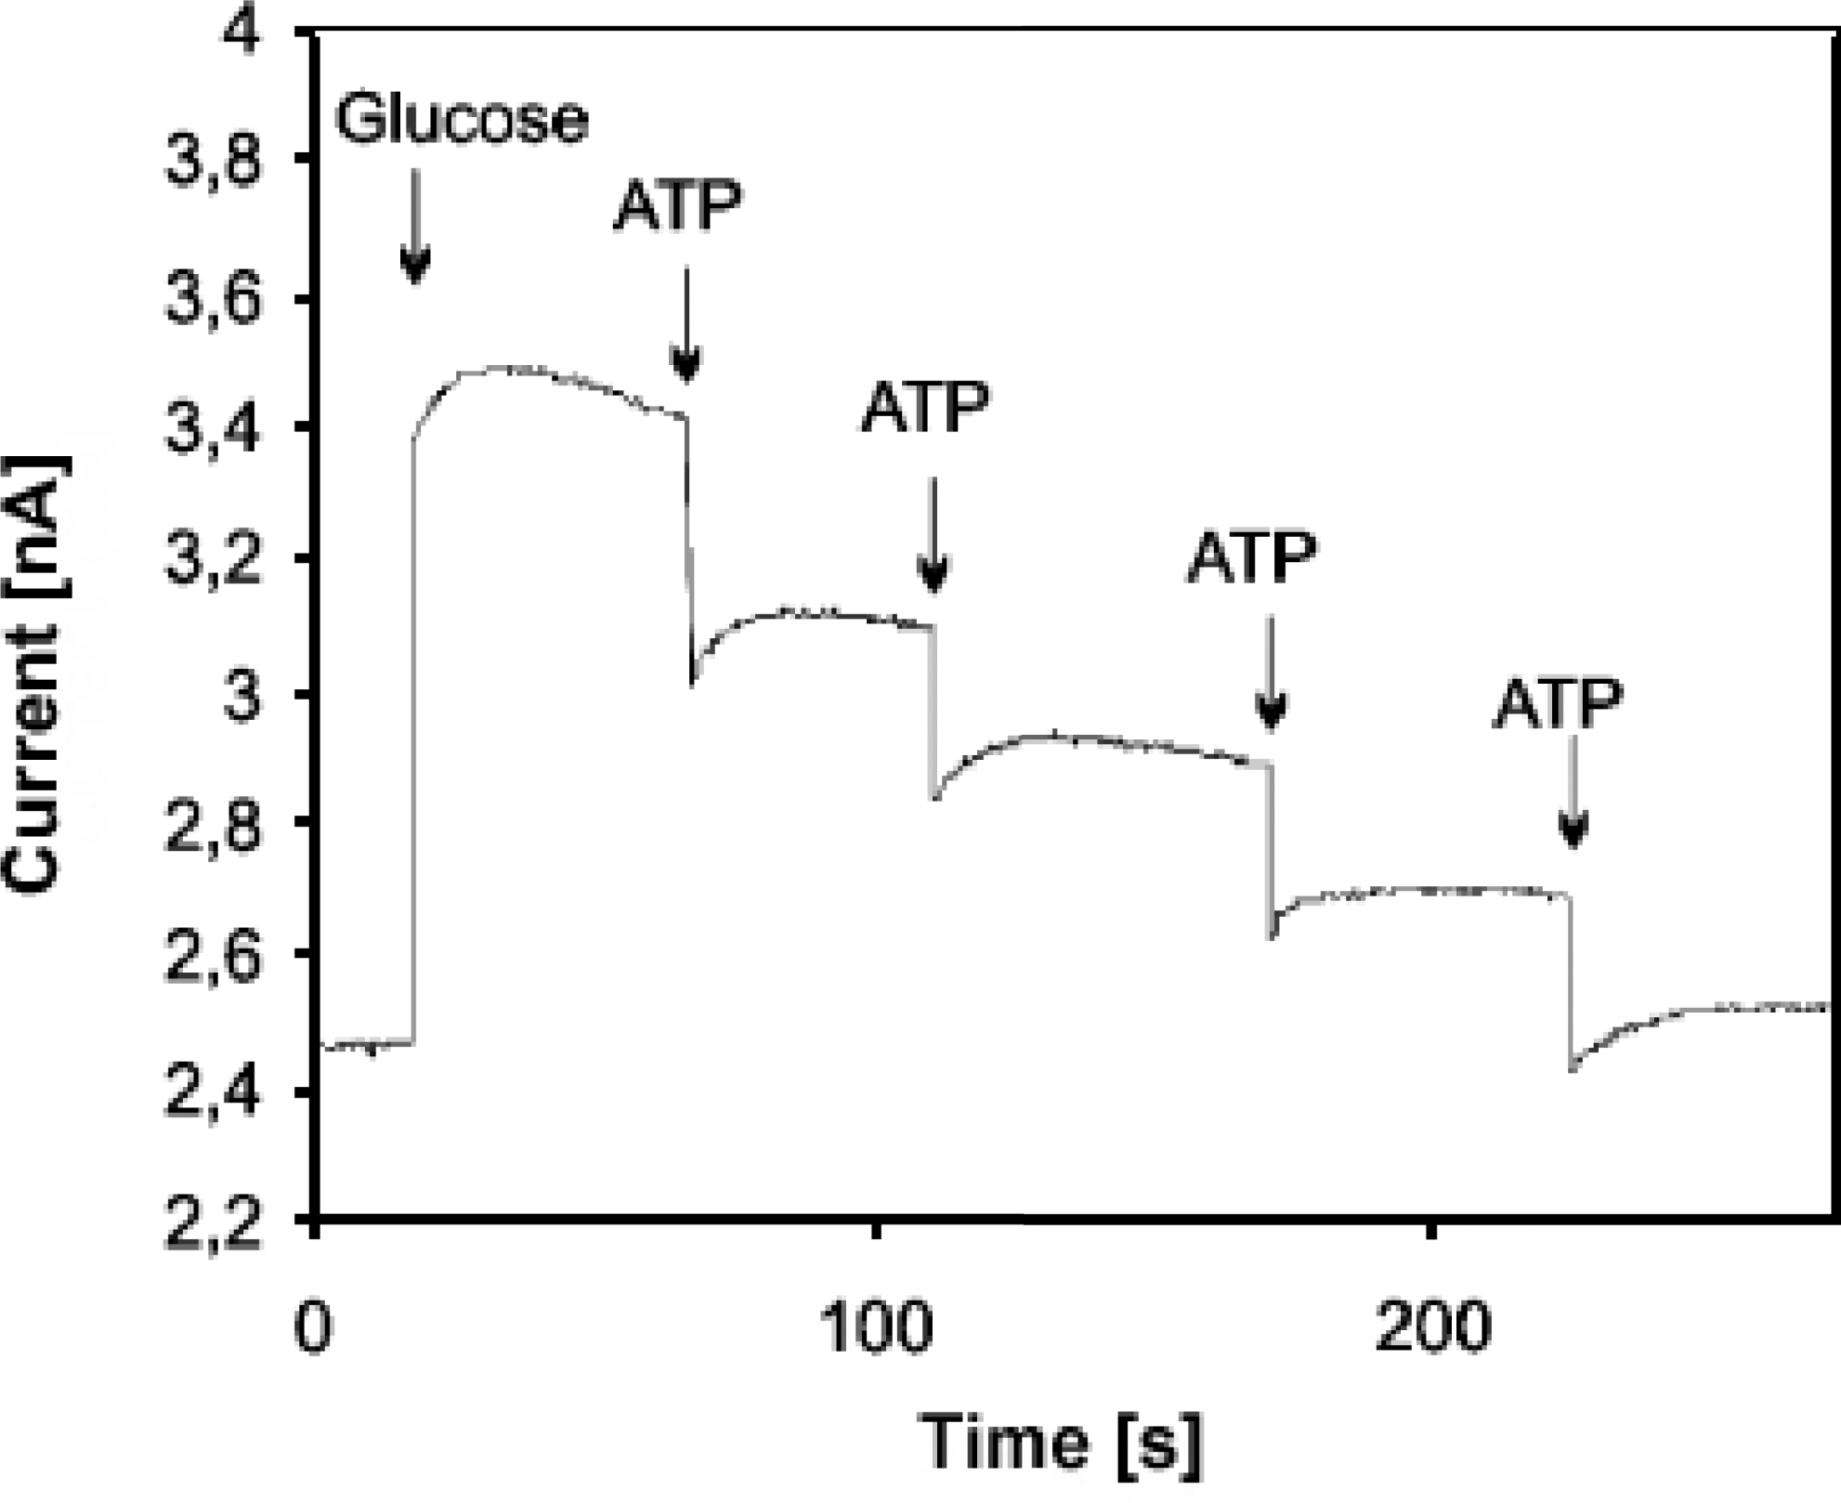

Potentiometry: Potentiometric devices measure the accumulation of a charge potential at the working electrode compared to the reference electrode in an electrochemical cell when zero or no significant current flows between them. In other words, potentiometry provides information about the ion activity in an electrochemical reaction. For potentiometric measurements, the relationship between the concentration and the potential is governed by the Nernst equation, where Ecell represents the observed cell potential at zero current. This is sometimes also refered to as the electromotive force or EMF.[33]

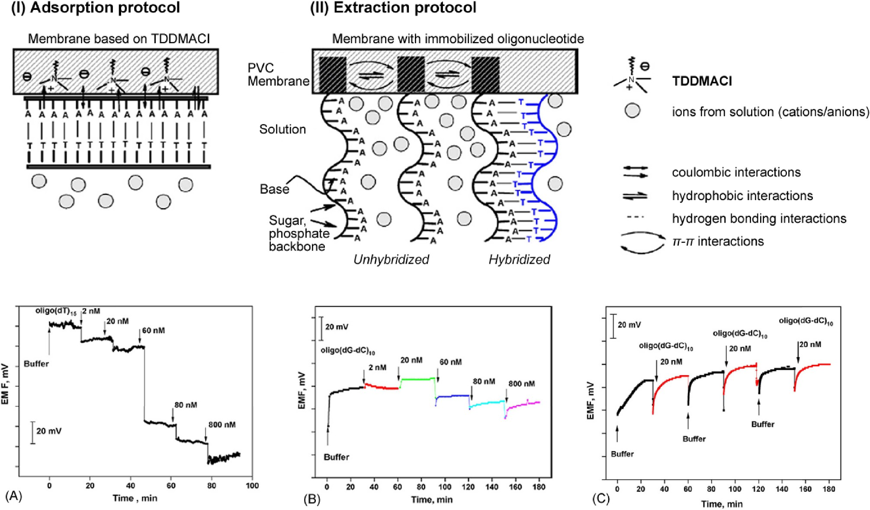
EMF or Ecell = E0 cell − RT nF lnQ

Impedance spectroscopy: The first publication of electrochemical impedance spectroscopy dates to 1975. Through the application of a small sinusoidally varying potential U, one measures the resulting current response I . By varying the excitation frequency f of the applied potential over a range of frequencies, one can calculate the complex impedance, sum of the real and imaginary impedance components, of the system as a function of the frequency (i.e. angular frequency w). Therefore, EIS combines the analysis of both real and imaginary components of impedance, namely the electrical resistance and reactance, as shown in Equation .

Z(jw) = U(jw) I(jw) = Zr(w)+jZi(w); w = 2πf (3)

EIS possesses the ability to study any intrinsic material property or specific processes that could influence the conductivity/resistivity or capacitivity of an electrochemical system.[33]
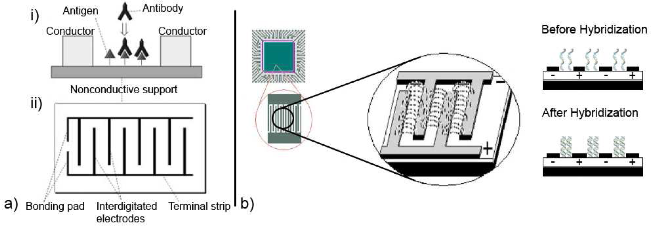

Voltammetry: Voltammetry belongs to a category of electro-analytical methods, through which information about an analyte is obtained by varying a potential and then measuring the resulting current. It is, therefore, an amperometric technique. Since there are many ways to vary a potential, there are also many forms of voltammetry, such as: polarography (DC Voltage) , linear sweep, differential staircase, normal pulse, reverse pulse, differential pulse and more . Cyclic voltammetry is one of the most widely used forms and it is useful to obtain information about the redox potential and electrochemical reaction rates (e.g. the chemical rate constant) of analyte solutions.[33]
Each mode is influenced by inherent noise mechanisms depending on electrode kinetics, diffusion regimes, and available charge carriers.

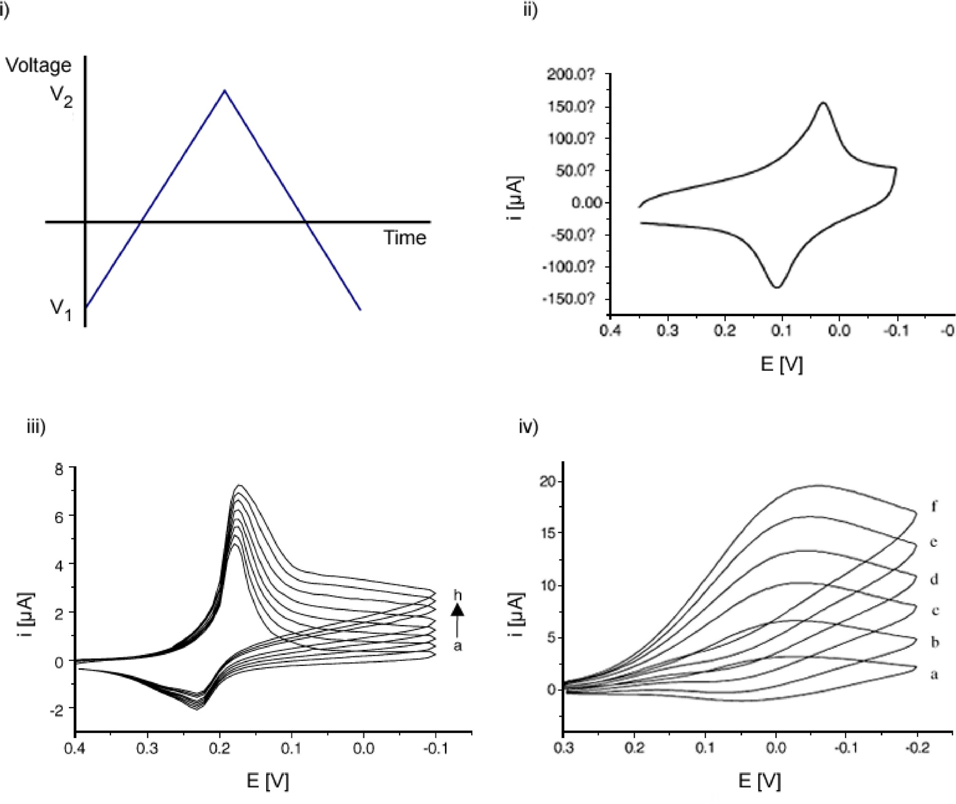
.
B. Electrochemical MEMS Fabrication and Integration
Electrochemical MEMS fabrication for modern sensors combines microfabricated thin-film electrodes (Au, Pt, graphene, CNTs) produced by sputtering or evaporation followed by photolithography and lift-off, often on Si/SiO₂ or polymeric substrates, with microfluidic channels formed by soft lithography of PDMS or deep reactive ion etching (DRIE) of silicon bonded to glass. In lab-on-CMOS platforms, post-CMOS micromachining planarizes the chip and carrier surface to within sub-100 nm, enabling photolithographic patterning of TiW–Au or Ti–Pt electrodes on top of passivation layers, and routing metal interconnects to the periphery for subsequent bonding of microchannels, reservoirs, and packaging structures for electrochemical measurements in flow. Integration of graphene and CNT electrodes typically uses CVD growth on Cu followed by transfer and patterning or direct inkjet/ spray deposition, offering high surface area and fast electron transfer, but requiring careful process-temperature control to remain
CMOS compatible. Flexible and stretchable electrochemical MEMS are realized on PI, PET, PDMS, or elastomeric substrates, using thin metal meshes, serpentine interconnects, or nanocomposite conductors to preserve conductivity under bending and stretching, and can be further combined with microfluidic textiles or epidermal microchannels to guide sweat, interstitial fluid, or tears to the sensing area for wearable applications.
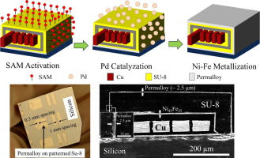

Monolithic or “lab-on-CMOS” integration places low-noise potentiostats, ADCs, and multiplexers directly beneath or beside the electrodes, minimizing parasitic impedance and enabling dense sensor arrays and multiparametric monitoring but also introducing new noise and reliability challenges from close proximity of electronics, electrolytes, and mechanical structures. Mechanical noise arises from substrate bending, vibrations, and strain in stretchable conductors, modulating contact resistance and double-layer capacitance; environmental noise originates from temperature fluctuations, humidity, ionic strength variation, biofouling, and gas bubbles in microchannels; dielectric and electrical noise comes from leakage through passivation layers, trapped charges in dielectrics, electromagnetic coupling to digital circuitry, and 1/f noise in front-end devices, all of which are exacerbated by high-impedance
electrochemical interfaces and long microfluidic paths. Careful stack design (barrier/passivation layers, hydrophobic coatings), shielding and grounding schemes, differential readout, on-chip calibration, and mechanical decoupling structures (e.g., suspended membranes, strain-isolated islands on flexible substrates) are therefore essential to maintain signal integrity in these advanced electrochemical MEMS platforms while exploiting their benefits in miniaturization, wearability, and multiplexed sensing[34-48].

III. NOISE MECHANISMS IN ELECTROCHEMICAL MEMS BIOSENSORS
This review adopts a five-dimensional classification of noise mechanisms.
A. Device-Level Electronic Noise

Electrochemical MEMS biosensors inherit fundamental electronic noise from materials and passive elements that set the baseline limit of detection. Thermal (Johnson–Nyquist) noise originates from random carrier motion in electrode resistance, interconnects, and feedback elements of the transimpedance amplifier (TIA); its power scales with resistance, temperature, and bandwidth, making careful resistance sizing and thermal management central to minimizing input‑referred current noise in amperometry front ends (e.g., using lower feedback resistors with appropriate gain partitioning) [Bard & Faulkner, 2001; Razavi, 2001]. Shot noise becomes relevant when discrete electron‑transfer events dominate at low currents, particularly in diffusion‑limited amperometry and high‑sensitivity enzymatic sensors; its magnitude scales with the DC current, so operating points, mediator chemistry, and electrode area all influence the effective shot contribution at the interface [Bard & Faulkner, 2001; Hassibi & Lee, 2005].

Flicker (1/f) noise is typically the dominant low‑frequency component, arising from surface traps, adsorption heterogeneity, electrode roughness, and semiconductor/oxide interfaces in CMOS input devices. In the analog front end, it sets the practical corner frequency where modulation or chopper stabilization becomes attractive to translate 1/f out of band; at the electrode, roughness and defect states make 1/f particularly sensitive to fabrication quality and post‑processing (e.g., polishing, SAM formation) [Vandamme, 1994; Razavi, 2001; Berney et al., 2000]. Co‑optimization—smoother interfaces, stable functional layers, and low‑flicker input transistors—reduces the aggregate 1/f contribution seen in PSDs and Allan deviation curves [Mallat, 1999; Allan, 1966].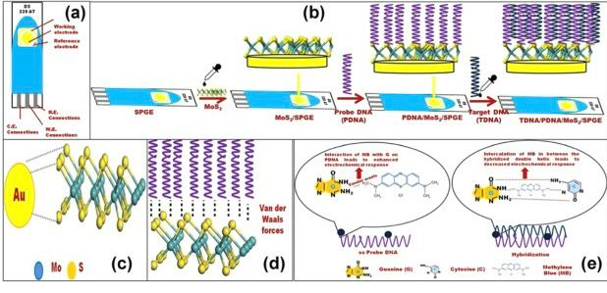
B. Electrochemical and Diffusion Noise
Ionic fluctuation noise reflects stochastic ion transport and concentration gradients within the diffusion layer, especially under low‑flow or stagnant microfluidic conditions. Random variations in double‑layer charge and ionic screening modulate interfacial impedance and faradaic currents, which appear as low‑frequency drift and excess variance in amperometric time series; tuning ionic strength and buffer composition stabilizes the double layer and reduces these fluctuations [Bard & Faulkner, 2001; Wang, 2006]. Adsorption–desorption noise arises when biomolecules or ions stochastically bind to and unbind from the surface, perturbing surface charge density and the effective active area; it is typically 1/f‑like and can be curtailed with antifouling coatings (e.g., PEG, zwitterions) and well‑packed SAMs [Wang, 2006; Berney et al., 2000].

Reaction kinetics noise stems from variability in electron‑transfer rates and intermediate states during redox reactions, particularly in heterogeneous catalysis or enzymatic cascades. When reaction steps have distributed rate constants or transient poisoning, the faradaic current exhibits shot‑like and flicker components that depend on potential, mediator choice, and catalytic site quality; kinetic stabilization via mediator optimization and controlled potentials reduces stochasticity [Bard & Faulkner, 2001; Hassibi & Lee, 2005]. Diffusion‑reaction coupling can be diagnosed and separated using impedance spectroscopy and time‑frequency analysis, clarifying whether mass transport or intrinsic kinetics dominate the observed noise [Macdonald, 1987; Mallat, 1999].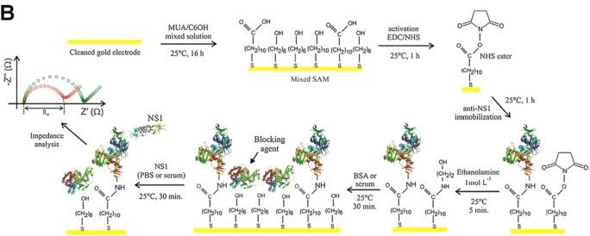

C. Interface and Dielectric Noise
Functional layers—SAMs, polymers, hydrogels, passivation stacks—introduce dielectric and interfacial noise through relaxation dynamics and structural changes. Dielectric relaxation in thin films and oxides produces frequency‑dependent fluctuations in impedance magnitude/phase, often modeled with constant phase elements; this appears as excess low‑frequency noise that tracks moisture content and film composition [Macdonald, 1987; Bard & Faulkner, 2001]. Polymer swelling and hydration dynamics modulate thickness, permittivity, and ion permeability, yielding slow drift and hysteresis in baseline signals; careful selection of crosslink density and solvent exposure protocols mitigates these effects [Madou, 2011; Wang, 2006].

Surface‑charge instability at partially covered or defective SAMs generates fluctuating local fields and trap dynamics that couple into 1/f current noise. Interfacial reactions—such as partial desorption, oxidation, or ligand exchange alter the density of active sites and double‑layer capacitance over time, contributing to drift that is detectable in EIS and long‑baseline amperometry; rigorous cleaning, SAM packing, and storage conditions improve stability [Bard & Faulkner, 2001; Berney et al.,2000]. Monitoring interface health via periodic impedance sweeps provides early warning of dielectric or interfacial degradation before elevates the noise floor.
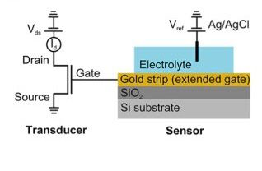
D. Electronic Readout Noise
The readout chain adds its own noise budget that must be matched to electrochemical limits. CMOS input devices exhibit flicker noise that dominates below the 1/f corner; chopper or auto‑zero techniques translate this noise to higher frequencies where it can be filtered, while proper device sizing and biasing reduce input‑referred noise without excessive power [Razavi, 2001; Harrison, 2009]. Resistors in the TIA feedback network contribute thermal noise that scales with resistance and bandwidth; partitioning gain between resistor and active elements, and limiting bandwidth to the signal region, lowers total noise [Razavi, 2001; Proakis & Manolakis, 2006].
Quantization noise from ADCs becomes relevant when SNR is high and resolution is limited; oversampling and dithering improve effective number of bits and smooth spectral artifacts, especially near low‑frequency bands used in biosensors [Proakis & Manolakis, 2006]. Parasitic capacitances—at the electrode, cabling, and PCB—introduce poles/zeros that shape noise and can couple environmental interference into the TIA; careful layout, guarding, and input shielding are essential to preserve stability and keep input‑referred currents low [Senturia, 2001; Razavi, 2001]. End‑to‑end budgeting of input noise density and loop stability ensures the analog front end does not bottleneck detection limits established by electrochemistry [Harrison, 2009].

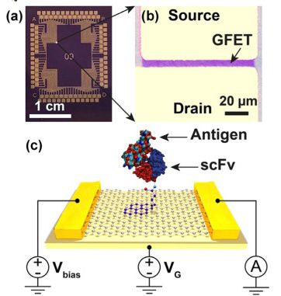

E. Environmental and Packaging Noise
Environmental and packaging factors often dominate in real‑world operation, especially in wearable and implantable formats. Electromagnetic interference (EMI) from radios, motors, and digital logic couples into high‑impedance sensor nodes; shielding (Faraday cages), differential routing, star grounding, and guard rings significantly attenuate common‑mode pickup and radiated noise [Razavi, 2001; Senturia, 2001]. Mechanical vibrations and motion induce microfluidic and contact instabilities that manifest as low‑frequency drift and transient spikes; compliant mounts, mechanical damping, and flow stabilizers reduce motion artifacts in on‑body systems [Madou, 2011; Hagleitner et al., 2002].
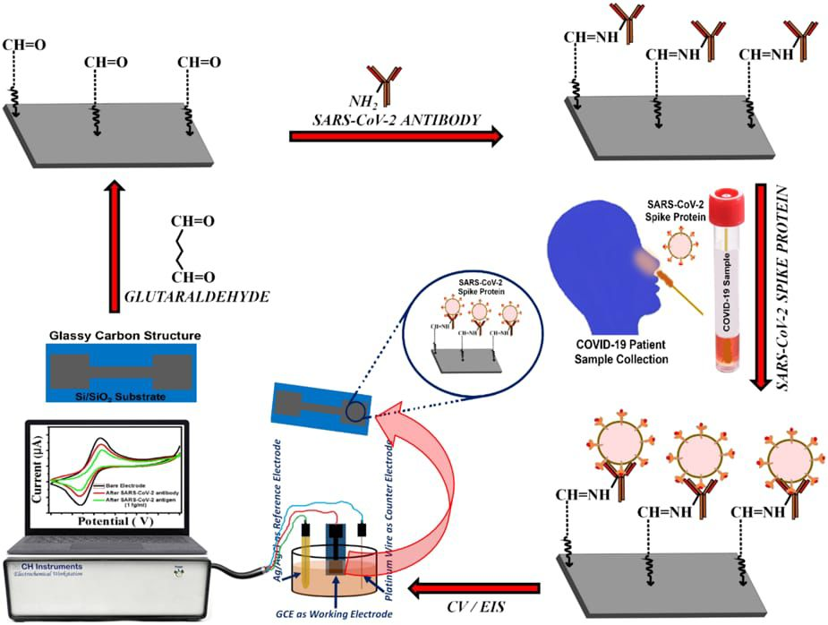

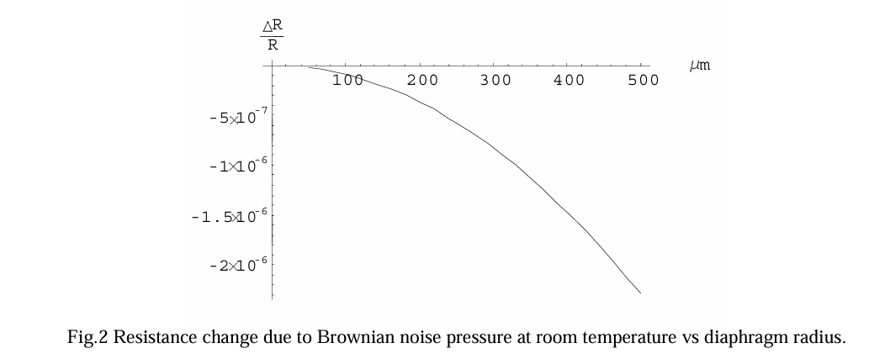

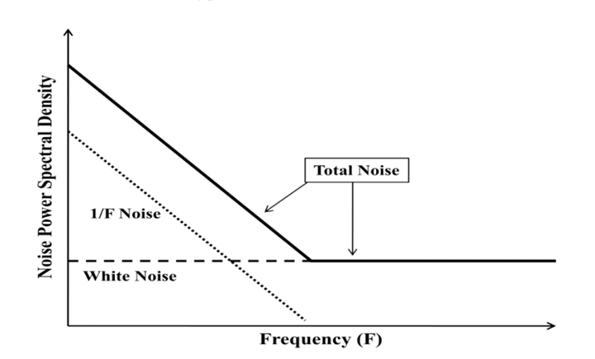
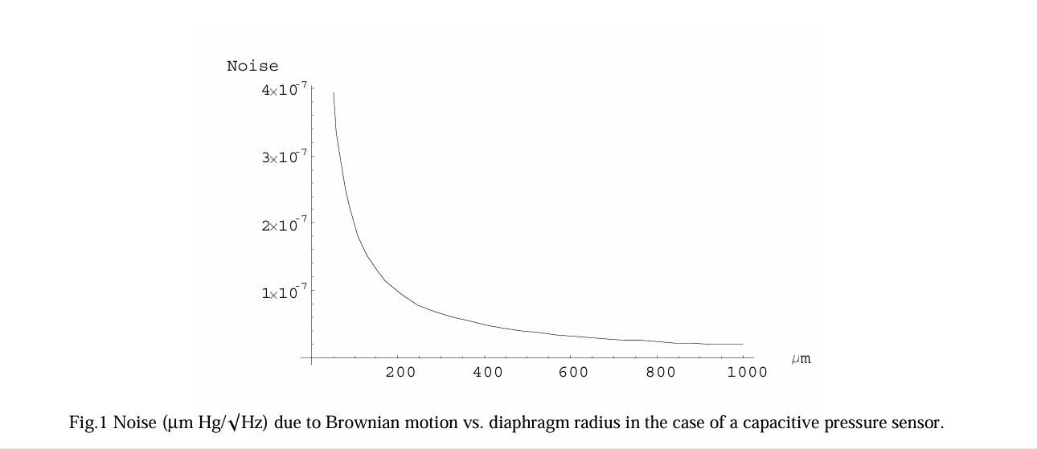

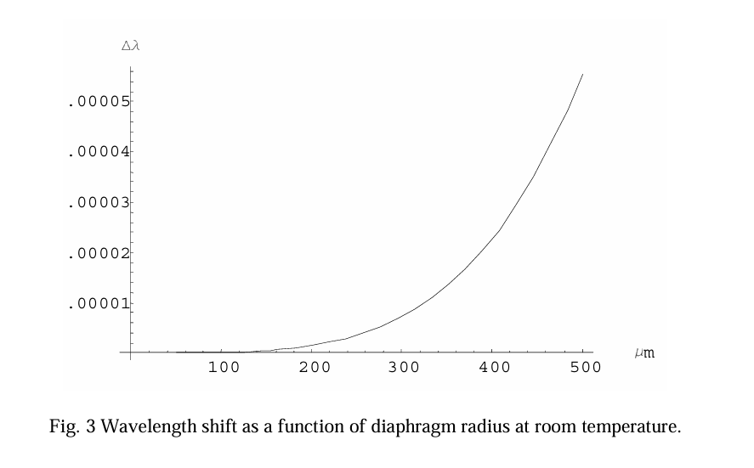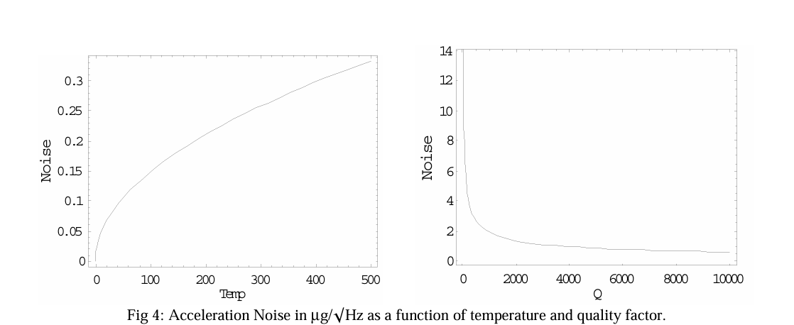

IV. EFFECT OF NOISE ON SENSOR PERFORMANCE
Noise influences performance in several critical ways:
- Detection Limit (LOD): Noise sets the minimum measurable signal above background fluctuations. In electrochemical sensors, random current and voltage noise restrict sensitivity, making ultra‑low analyte concentrations difficult to detect.
- Signal-to-Noise Ratio (SNR): A high SNR is essential for reliable and precise measurements. Noise reduces SNR, increasing uncertainty in quantitative analysis and degrading biosensor reproducibility..
- Baseline Drift: Accumulated noise shifts the baseline signal over time, complicating continuous monitoring such as glucose or neurotransmitter detection.
- Impedance Accuracy (EIS): In electrochemical impedance spectroscopy, noise distorts Nyquist and Bode plots, leading to errors in modeling biochemical interactions and reducing interpretive accuracy.
- Selectivity: Noise can mimic or suppress analyte signatures, producing false positives or negatives. This undermines selectivity, especially in complex biological matrices.

- Response Time: Fluctuations interfere with adaptive filtering and feedback loops, slowing sensor stabilization and delaying accurate output.
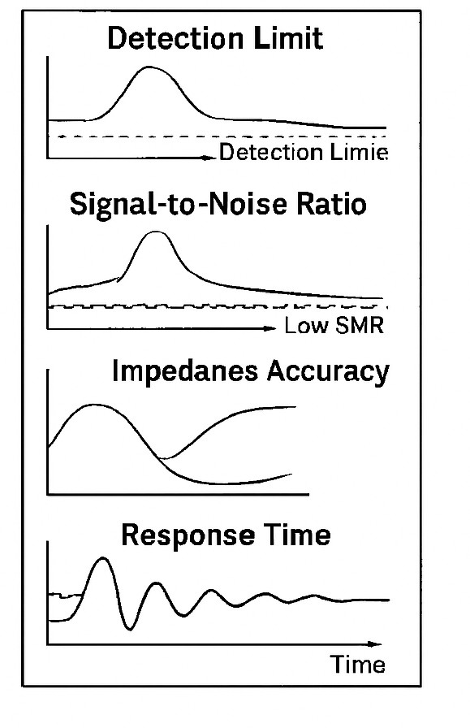

V. NOISE CHARACTERIZATION TECHNIQUES
Noise characterization in electrochemical MEMS biosensors is essential for understanding the fundamental limits of detection and for designing effective mitigation strategies. Because noise arises from multiple sources—electrode interfaces, diffusion processes, dielectric relaxation, and electronic readout circuits—different analytical approaches are required to capture its full complexity. The following techniques are widely employed in biosensor research.

- Frequency-Domain Analysis
Frequency-domain analysis is the most common approach, where the power spectral density (PSD) is used to distinguish between spectrally flat white noise and low-frequency 1/fnoise [1]. Thermal noise manifests as a constant PSD across frequencies, while flicker noise dominates at low frequencies, often below 100 Hz. Shot noise, arising from discrete electron-transfer events, appears as a frequency-independent contribution proportional to current. PSD analysis has been applied extensively in electrochemical sensors to quantify noise floors and identify dominant mechanisms [2]. Advanced methods such as Welch’s periodogram and multitaper spectral estimation reduce variance in PSD measurements, improving accuracy in biosensor characterization [3].

- Time-Domain Methods
Time-domain methods complement spectral analysis by capturing drift and nonstationary behaviour. Autocorrelation functions reveal memory effects in electrode interfaces, while variance analysis detects heteroscedasticity in biosensor signals [4]. Allan deviation, originally developed for frequency stability studies, is particularly useful in biosensors to distinguish between white noise, flicker noise, and random walk processes [5]. For example, Allan variance analysis has been used to quantify baseline drift in continuous glucose monitoring systems, providing insights into long-term stability [6].

- Electrochemical Impedance Spectroscopy (EIS)
Electrochemical impedance spectroscopy (EIS) is a powerful tool for extracting interfacial noise signatures. By probing the frequency-dependent impedance of the electrode–electrolyte interface, EIS separates contributions from charge-transfer resistance, double-layer capacitance, and diffusion processes [7]. Noise manifests as variability in impedance magnitude and phase, which can be modelled using equivalent circuits such as the Randles cell [8]. EIS has been widely applied in biosensors to study adsorption–desorption noise, dielectric relaxation, and polymer swelling effects [9]
- Statistical Analysis in Microelectrode Arrays
Statistical analysis in microelectrode arrays provides spatial information about noise. By mapping correlated versus uncorrelated noise across electrode grids, researchers can distinguish global disturbances such as electromagnetic interference from local noise sources like electrode fouling [10]. Techniques such as principal component analysis (PCA) and cross-correlation have been used to identify common-mode noise in CMOS-integrated biosensor arrays [11]. This approach is particularly valuable in high-density biosensor platforms, where distinguishing electrode-specific noise from system-wide fluctuations is critical [12].

- Transient and Multiresolution Analysis
Wavelet decomposition identifies short-lived noise events.

VI. NOISE MITIGATION STRATEGIES
A. Electrode Design and Materials Engineering
1) Low-Noise Electrode Materials
The choice of electrode material plays a pivotal role in mitigating noise in electrochemical MEMS sensors. Noble metal thin films such as gold and platinum are widely employed due to their excellent conductivity, chemical stability, and low intrinsic noise, making them reliable for long‑term biosensing[1]. Graphene and other 2D materials provide atomically thin, defect‑controlled surfaces with high electron mobility, which significantly reduce 1/f noise and enhance signal fidelity[2]. Carbon nanotube (CNT) electrodes, with their high aspect ratio and conductive networks, improve charge transfer kinetics and suppress background fluctuations, thereby lowering detection limits[3]. More recently, MXenes have emerged as promising candidates owing to their tunable surface chemistry, hydrophilicity, and stable redox properties, which help minimize interfacial noise and improve reproducibility in complex biological environments[4]. Together, these material innovations form the foundation of low‑noise electrode design strategies in modern electrochemical MEMS biosensors.

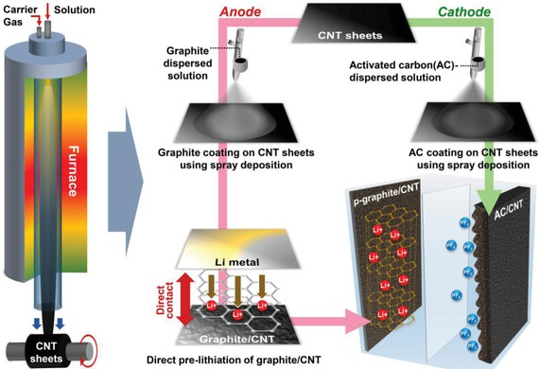
2) Surface Functionalization
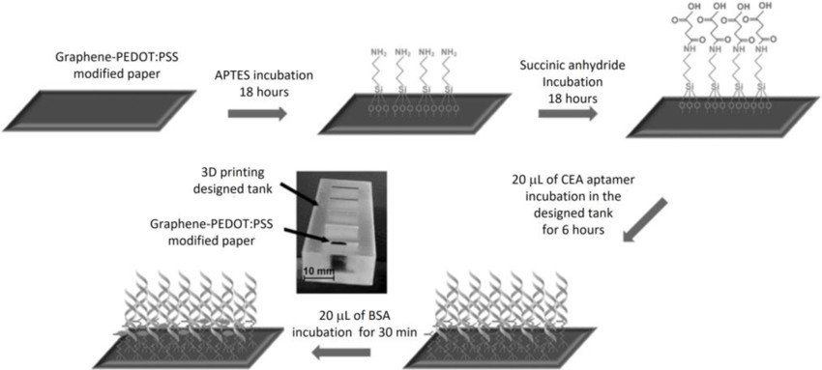
Tailored surface functionalization is a critical strategy for reducing electrochemical noise in MEMS biosensors by stabilizing the electrode–electrolyte interface and suppressing nonspecific interactions. Self‑assembled monolayers (SAMs), typically formed from thiols on gold, provide ordered molecular films that minimize interfacial defects and reduce charge‑transfer variability, thereby lowering baseline noise[1]. Conductive polymers such as PEDOT:PSS offer both high electrical conductivity and mechanical flexibility, enabling efficient charge transport while dampening 1/f noise and improving long‑term stabilit[2]y. Anti‑fouling coatings, including polyethylene glycol (PEG) and zwitterionic layers, prevent nonspecific protein adsorption and biofouling, which are major sources of drift and low‑frequency noise in continuous monitoring applications[3]. Collectively, these functionalization strategies enhance signal fidelity, extend sensor lifetime, and form a cornerstone of noise mitigation in electrochemical MEMS biosensors.
3) Geometric Optimization
Electrode geometry plays a decisive role in noise mitigation for electrochemical MEMS biosensors. Smaller electrodes inherently reduce double‑layer capacitance and thermal noise, thereby improving signal stability and lowering detection limits. Beyond
simple miniaturization, fractal and nano‑patterned electrode architectures provide a dramatic increase in effective surface area
while maintaining compact footprints, which enhances charge‑transfer efficiency and reduces interfacial resistance. Such designs also shorten diffusion paths and average local fluctuations, leading to improved reproducibility and reduced 1/f noise.
Collectively, geometric optimization strategies—ranging from nanoscale miniaturization to fractal patterning—form a critical foundation for achieving high signal‑to‑noise ratios in MEMS biosensors.

.B. Circuit-Level Noise Suppression
- Chopper-Stabilized and Auto-Zero Amplifiers
Beyond electrode and material engineering, circuit design plays a pivotal role in reducing intrinsic noise in electrochemical MEMS biosensors. Chopper‑stabilized and auto‑zero amplifiers are widely employed to suppress low‑frequency flicker (1/f) noise by modulating the input signal to a higher frequency band where noise is less dominant, followed by synchronous demodulation. This modulation/demodulation process effectively cancels offset drift and minimizes baseline fluctuations, thereby improving signal fidelity in low‑current electrochemical measurements. Auto‑zero techniques further enhance stability by periodically sampling and subtracting offset voltages, which is particularly beneficial for long‑term biosensing in noisy environments. Together, these circuit‑level strategies complement electrode and material optimization, forming an integrated approach to noise mitigation in MEMS biosensors.

- Low-Noise Transimpedance Amplifier (LNA-TIA) Architectures
In electrochemical MEMS biosensors, the transimpedance amplifier (TIA) is a critical front‑end circuit that converts low‑level electrode currents into measurable voltages. Noise suppression in TIAs is achieved through careful optimization of feedback resistors, which balance gain and thermal noise contributions. Capacitive compensation is often introduced to stabilize the amplifier and suppress high‑frequency noise, ensuring reliable operation under varying electrode impedances. Differential readout architectures further enhance noise rejection by canceling common‑mode disturbances and improving signal fidelity in multiplexed sensor arrays. Collectively, these circuit‑level strategies enable LNA‑TIA designs to achieve high sensitivity and low detection limits, complementing electrode and material engineering approaches for comprehensive noise mitigation in MEMS biosensors.

- Filtering and Modulation
Signal conditioning through filtering and modulation is a powerful approach to suppress noise in electrochemical MEMS biosensors. Lock‑in amplification enables selective detection of weak electrochemical signals by modulating the input and synchronously demodulating at a reference frequency, thereby rejecting broadband and 1/f noise. Analog low‑pass filters are commonly integrated into readout circuits to attenuate high‑frequency interference and thermal noise, ensuring stable baseline measurements. Oversampling combined with Σ–Δ modulation further enhances resolution by spreading quantization noise across a wider bandwidth and shaping it outside the signal band, which is then removed by digital filtering. Together, these techniques provide robust circuit‑level noise suppression, complementing electrode and material optimization strategies to achieve high signal‑to‑noise ratios in MEMS biosensors.
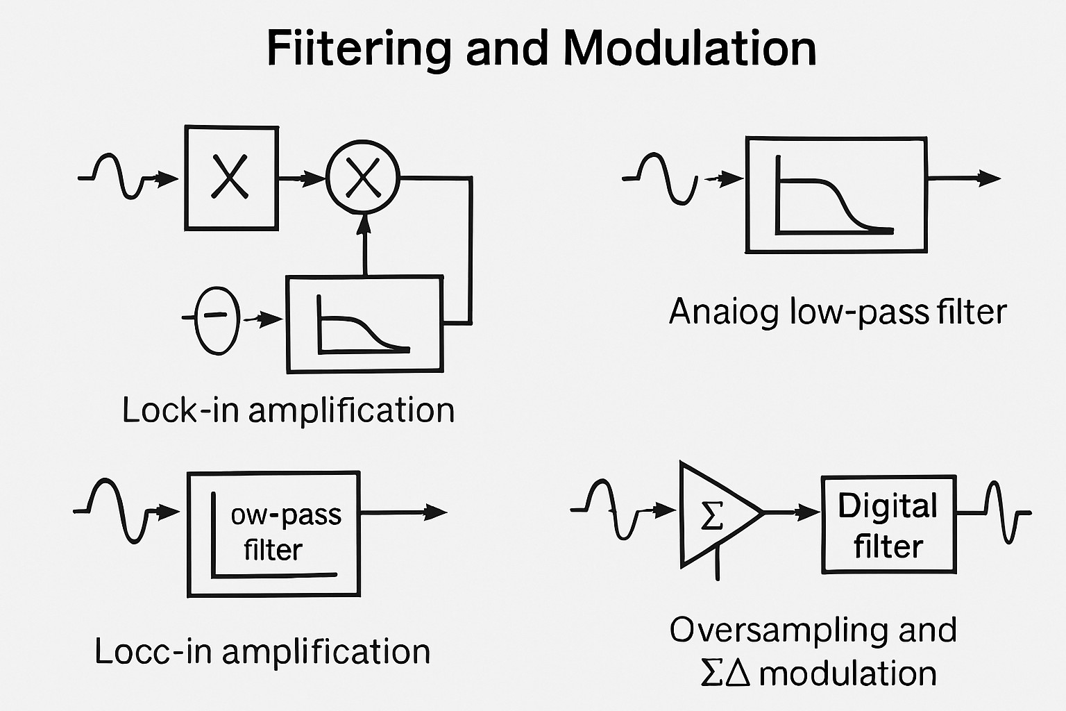

C. Signal Processing and AI-Based Noise Reduction
1) Adaptive Digital Filters
Advanced signal processing techniques are increasingly applied to suppress noise in electrochemical MEMS biosensors. Kalman filtering provides optimal recursive estimation by modeling system dynamics and measurement noise, making it effective for tracking low‑current biosensor signals in real time. Least‑Mean‑Square (LMS)
adaptive filters offer computationally efficient noise cancellation by iteratively adjusting filter coefficients to minimize error, which is particularly useful for biosensors operating in dynamic environments. Wavelet denoising further enhances signal fidelity by decomposing biosensor signals into multiple scales, isolating noise components, and reconstructing clean signals without distorting transient features. Collectively, these adaptive digital filtering strategies complement hardware‑level noise suppression, enabling robust detection of weak electrochemical signals in MEMS biosensors.

2) Machine Learning Denoising
Machine learning approaches are increasingly applied to denoise electrochemical MEMS biosensor signals by learning typical noise patterns and distinguishing them from true biochemical responses. Neural networks, particularly convolutional and recurrent architectures, can be trained on large datasets of biosensor signals to identify and suppress stochastic fluctuations, baseline drift, and environmental interference. These models outperform traditional filters by adapting to nonlinear and time‑varying noise characteristics, enabling robust detection of weak electrochemical signals. Deep learning‑based denoising thus represents a powerful complement to hardware‑level noise suppression, offering enhanced sensitivity and reproducibility in MEMS biosensors.

3) Drift Compensation
Long‑term stability of electrochemical MEMS biosensors is often compromised by baseline drift caused by electrode fouling, environmental changes, or material degradation. Auto‑regressive models provide predictive correction by modeling temporal dependencies in sensor output, allowing real‑time compensation of drift. Baseline correction algorithms, including polynomial fitting and adaptive subtraction, further enhance accuracy by continuously recalibrating sensor responses against reference signals. These computational strategies extend sensor lifetime and reliability, ensuring consistent performance in continuous monitoring applications.

D. Microfluidic, Packaging, and Environmental Control
Environmental and packaging strategies are critical for suppressing external and systemic noise in electrochemical MEMS biosensors. Microfluidic dampers reduce diffusion‑related fluctuations by stabilizing analyte transport and minimizing convection artifacts, thereby improving reproducibility in confined sensing volumes. Electromagnetic interference (EMI) shields, often implemented with conductive enclosures or grounded packaging, protect sensitive readout circuits from external noise sources. Temperature control elements, including micro‑heaters and thermoelectric stabilizers, suppress drift by maintaining consistent operating conditions and compensating for thermal variations. Flexible packaging with mechanical decouplers further reduces vibration‑induced artifacts, ensuring stable sensor performance in portable and wearable applications. Collectively, these microfluidic, packaging, and environmental control strategies complement electrode and circuit‑level noise mitigation, enabling robust biosensing in real‑world environments.
VII. COMPARATIVE EVALUATION OF NOISE MITIGATION TECHNIQUES
Level / strategy | Mechanism | Advantages | Limitations | Representative sources
Advanced electrode materials | Use Au/Pt, graphene, CNTs, MXenes to lower interfacial fluctuations and improve charge transfer | Lower LOD, better stability | Material variability; process complexity | Bard & Faulkner [1]; Wang [2]; Novoselov et al. [3]
Geometry and scaling optimization | Tailor electrode area, spacing, and shape to reduce impedance and diffusion noise | Higher SNR; predictable spectra | Trade-offs with mass transport; layout constraints | Senturia [4]; Kovacs [5]
Surface roughness control | Polishing, annealing, controlled nano roughness to stabilize double layer | Reduces 1/f-like interface noise | Aging and fouling can change roughness | Bard & Faulkner [1]; Madou [6]
Passivation and protective coatings | Thin oxides, ALD, parylene to stabilize dielectric properties | Reduces dielectric drift, improves long-term stability | Added capacitive parasitises | Madou [6]; El-Hak [7]
Antifouling layers (PEG, zwitterions) | Minimize nonspecific adsorption (adsorption–desorption noise) | Better baseline; fewer false positives | Limited lifetime in biofluids | Wang [2]; Berney et al. [8]
Self-assembled monolayers (SAMs) | Chemically stable capture layers to reduce interface stochasticity | Improved reproducibility | Sensitivity to chemistry and storage | Bard & Faulkner [1]; Li et al. [9]
Nano structuring (arrays, nanowires) | Increase effective area while controlling local fields | Boost sensitivity without raising current noise | Fabrication complexity; variability | Kovacs [5]; Madou [6]
Redox mediator optimization | Use stable mediators to regularize ET kinetics | Lower shot-like fluctuations; repeatable amperometry | Chemical management complexity | Bard & Faulkner [1]; Hassibi et al. [10]
Buffer and electrolyte tuning | Ionic strength/pH optimization to stabilize double layer | Lower ionic fluctuation noise | May affect affinity/kinetics | Wang [2]; Bard & Faulkner [1]
Temperature regulation | On-chip heaters, thermal compensation | Reduces drift; stabilizes kinetics | Higher power budget | El-Hak [7]; Harrison [11]
Microfluidic flow control | Laminar flow, dampers to reduce turbulence and bubbles | Lower concentration and convection noise | Clogging risk; design complexity | Madou [6]; Li et al. [9]
Bubble management and degassing | Hydrophobic vents, pre-degas protocols | Prevents transient spikes and impedance jumps | Added packaging steps | Madou [6]
EMI shielding and grounding | Faraday cages, guard rings, star-ground topology | Suppresses external electromagnetic noise | Space/cost; careful layout needed | Razavi [12]; El-Hak [7]
Mechanical isolation | Compliant mounts, damping materials | Reduces vibration-induced artifacts | Packaging complexity | Senturia [4]
Differential/reference electrode schemes | Differential sensing; robust reference electrode design | Common-mode rejection; baseline stability | Additional electrodes; calibration | Bard & Faulkner [1]
Low-noise TIA co-design | Optimize feedback R/C, input devices, stabilize bias | Lower input-referred current noise | Design effort; area/power | Harrison [11]; Razavi [12]
Chopper/auto-zero amplification | Modulate to move 1/f out of band; demodulate | Excellent flicker suppression | Switching artifacts; power | Razavi [12]
Lock-in detection | Phase-sensitive detection at a known modulation | High rejection of broadband noise | Requires stable modulation | Proakis & Manolakis [13]
ADC oversampling/dithering | Average and add dither to linearize quantization | Better ENOB; smoother spectra | Data rate/power increase | Proakis & Manolakis [13]
Correlated double sampling (CDS) | Subtract successive samples to cancel low-frequency drift | Simple; effective on slow drift | Reduces low-frequency signal too | Haykin [14]
Wavelet denoising | Multiresolution thresholding of transient/noise bands | Preserves events; removes bursts | Parameter tuning; computation | Mallat [15]; Savran et al. [16]
Kalman/adaptive filters (LMS) | Model-based and adaptive suppression of drift and residuals | Strong performance in wearables | Requires models/tuning | Haykin [14]
Allan variance-based stabilization | Choose averaging that minimizes combined noise | Objective drift/white balance | Requires stationarity windows | Allan [17]
PCA/ICA and array redundancy | Separate common-mode vs. local noise across grids | Robust multi-electrode operation | Needs datasets; cross-talk handling | Gupta et al. [18]; Berney et al. [8]
Multi-sensor fusion | Combine electrochemical + environmental channels | Compensates environmental noise | Alignment and calibration effort | Senturia [4]
AI-driven denoising | Deep nets for real-time denoise/drift removal | High effectiveness in IoT/wearables | Training data; compute | Goodfellow et al. [19]
Baseline subtraction and referencing | Continuous background tracking and removal | Simple; low-cost improvement | Sensitive to baseline model | Proakis & Manolakis [13]
Duty-cycling and quiet periods | Schedule measurement away from noisy operations | Reduces coupled digital/EMI noise | Throughput constraints | Razavi [12]

VIII. EMERGING DIRECTIONS AND FUTURE TRENDS
A. CMOS–MEMS Co-Design for Noise Minimization
Integrating MEMS electrodes with custom CMOS electronics in a co‑design framework reduces parasitic capacitance, leakage currents, and interconnect noise. By unifying sensor and circuit design, parasitic elements are minimized, enabling low‑noise amplification and improved signal fidelity. This approach is particularly effective for miniaturized biosensors where electrode impedance and circuit parasitics strongly influence noise performance.
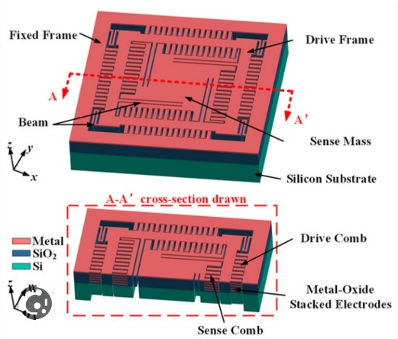
B. 2D and Nanostructured Materials
Advanced materials such as graphene, MoS₂, MXenes, and nanoporous metals exhibit inherently low interfacial noise due to high conductivity, large surface area, and reduced charge trapping. Their unique electronic properties enhance electrochemical transduction while minimizing flicker noise and drift. These materials also enable stable electrode interfaces, improving reproducibility in MEMS biosensors.
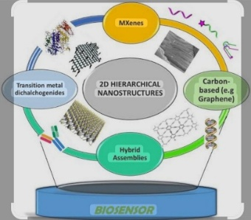

C. AI-Assisted Biosensing
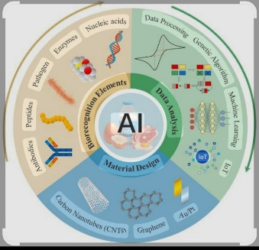
Machine learning algorithms are increasingly integrated into biosensor platforms to enhance denoising, drift compensation, fault detection, and lifetime prediction. Neural networks and adaptive models can learn complex noise patterns, distinguish them from true biochemical signals, and provide real‑time correction. AI‑assisted biosensing thus complements hardware‑level noise suppression with intelligent signal processing.

D. Hybrid Photonic–Electrochemical Architectures
Coupling electrochemical sensing with photonic referencing provides an orthogonal measurement modality that suppresses noise from electrochemical fluctuations. Optoelectronic integration enables referencing against optical signals, reducing baseline drift and enhancing sensitivity. Hybrid architectures are particularly promising for multiplexed biosensing where electrochemical noise can obscure weak signals.
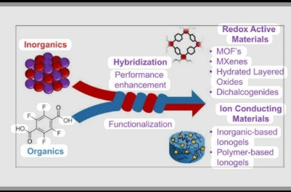

E. Self-Calibrating Biosensors
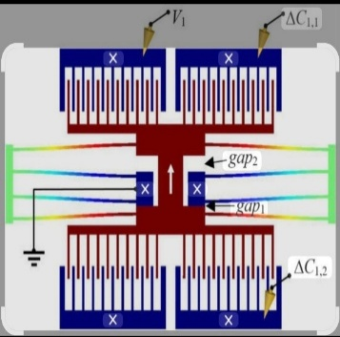
Self‑calibration strategies employ embedded microstimulus signals or reference electrodes to continuously correct sensor drift and offset. By periodically stimulating the system and recalibrating against known baselines, biosensors maintain stable performance in dynamic environments. This approach extends sensor lifetime and ensures reliable operation in long‑term monitoring applications.

IX. FUTURE ROADMAP FOR ULTRA-LOW-NOISE MEMS BIOSENSORS [May include in previous section or omit ]
The following priorities will shape next-generation biosensors:
- Integrated noise-aware MEMS + circuit co-design.
- Universal biosensor noise databases for AI training.
- Ultra-low-frequency drift compensation algorithms.
- Nanomaterial-based electrode solutions for interface stability.
- Energy-efficient low-noise amplifiers for wearable/implantable systems.
- Scalable monolithic CMOS-MEMS manufacturing for commercial viability.

X. CONCLUSION
Noise is no longer a secondary consideration but a defining limitation in electrochemical MEMS biosensor performance. By integrating innovations in material science, MEMS engineering, CMOS circuit design, microfluidics, packaging, and AI-assisted signal processing, modern biosensors can achieve unprecedented sensitivity, stability, and practicality. This review offers a holistic perspective and presents a forward-looking roadmap for the development of ultra-low-noise electrochemical MEMS biosensing platforms.

ACKNOWLEDGMENT
(Optional section)

REFERENCES
- Van der Ziel, A. Noise in Solid State Devices and Circuits. Wiley, 1986.
- Bard, A. J., & Faulkner, L. R. Electrochemical Methods: Fundamentals and Applications. Wiley, 2001.
- Pallas-Areny, R., & Webster, J. G. Sensors and Signal Conditioning. Wiley, 2001.
- Webster, J. G. Medical Instrumentation: Application and Design. Wiley, 2010.
- Harrison, R. R. Low-Power Analog Integrated Circuits for Neural Recording Applications. Springer, 2009.
- Fawcett, T. “ROC Graphs: Notes and Practical Considerations.” Pattern Recognition Letters, 2006.
- Madou, M. J. Fundamentals of Microfabrication and Nanotechnology. CRC Press, 2011.
- Kovacs, G. T. A. Micromachined Transducers Sourcebook. McGraw-Hill, 1998.
- Senturia, S. D. Microsystem Design. Springer, 2001.
- Yole Development Report on MEMS Market, 2010.
- Maluf, N. An Introduction to Microelectromechanical Systems Engineering. Artech House, 1999.
- Rebeiz, G. M. RF MEMS: Theory, Design, and Technology. Wiley, 2002.
- Pelesko, J. A., & Bernstein, D. H. Modeling MEMS and NEMS. Chapman & Hall, 2002.
- El-Hak, M. The MEMS Handbook. CRC Press, 2001.
- Hassibi, A. et al. “Noise in Affinity-Based Biosensors.” IEEE Transactions on Circuits and Systems, 2005.
- Gomri, S. et al. “Noise in Electrochemical Sensors.” Sensors and Actuators B, 2005.
- Kordas, J. et al. “Noise in CMOS-Compatible Electrodes.” IEEE Transactions, 1994.
- Li, Y. et al. “DNA Array Chip Noise Reduction.” Biosensors and Bioelectronics, 2003.
- Tu, J. et al. “Pre-hybridization in DNA Chips.” Biosensors and Bioelectronics, 2002.
- Savran, C. et al. “Noise in Biosensor Arrays.” Applied Physics Letters, 2002, 2003.
- Wang, J. Analytical Electrochemistry. Wiley, 2006.
- Kissinger, P. T., & Heineman, W. R. Laboratory Techniques in Electroanalytical Chemistry. Marcel Dekker, 1996.
- Razavi, B. Design of Analog CMOS Integrated Circuits. McGraw-Hill, 2001.
- Novoselov, K. S. et al. 2D Materials. Cambridge University Press, 2017.
- Goodfellow, I., Bengio, Y., & Courville, A. Deep Learning. MIT Press, 2016.
- Gupta, A. et al. “Noise in Biosensors.” IEEE Sensors Journal, 2004.
- Berney, H. et al. “Noise in Biosensor Systems.” Biosensors and Bioelectronics, 2000.
- Hagleitner, C. et al. “Noise in Biosensor Designs.” IEEE Journal of Solid-State Circuits, 2002.
- Haykin, S. Adaptive Filter Theory. Prentice Hall, 2002.
- Proakis, J. G., & Manolakis, D. G. Digital Signal Processing. Pearson, 2006.
- SpringerLink: MEMS-Based Biosensor.
- University of Edinburgh Lecture Notes: *Introduction to Electrochemical
- ELECTROCHEMICAL BIOSENSORS- SENSOR PRINCIPLES AND ARCHITECTURES BY Dorothee Grieshaber1, Robert MacKenzie1, Janos Voros1 and Erik Reimhult2.
- J. Wang, “Electrochemical biosensors: Towards point-of-care cancer diagnostics,” Biosensors and Bioelectronics, 2006.
- A. J. Bandodkar and J. Wang, “Wearable electrochemical sensors,” ACS Sensors, 2016.
- D. Erickson et al., “Nanomaterial-based microfluidic sensors,” Nature Nanotechnology, 2011.
- S. Carrara et al., “CMOS electrochemical biosensors,” IEEE Sensors Journal, 2010.
- H. Lee et al., “CMOS-integrated lab-on-a-chip systems,” Lab on a Chip, 2015.
- K. S. Novoselov et al., “Electric field effect in graphene,” Science, 2004.
- M. Pumera, “Graphene-based electrochemical sensors,” Electrochemistry Communications, 2010.
- P. Bergveld, “Thirty years of ISFET technology,” Sensors and Actuators B, 2003.
- Y. Liu et al., “Flexible and stretchable electrochemical sensors,” Advanced Materials, 2019.
- J. Rogers et al., “Epidermal electronics,” Science, 2011.
- A. Manz et al., “Micro total analysis systems,” Sensors and Actuators B, 1990.
- M. Madou, *Fundamentals of Microfabrication*, CRC Press.
- S. Shoji, “Microfluidic MEMS,” Microelectronic Engineering, 2000.
- C. Hierold et al., “Carbon nanotube sensors,” Sensors and Actuators A, 2007.
- E. Bakker, “Electrochemical noise and interference in sensors,” Analytical Chemistry, 2004.
- Bard, A. J., & Faulkner, L. R. Electrochemical Methods: Fundamentals and Applications. Wiley, 2001.
- Razavi, B. Design of Analog CMOS Integrated Circuits. McGraw-Hill, 2001.
- Hassibi, A., & Lee, T. H. “A General Noise Model for Capacitive Biomolecular Sensors.” IEEE Journal of Solid-State Circuits, 40(12), 2005.
- Vandamme, L. K. J. “Noise as a Diagnostic Tool for Quality and Reliability of Electronic Devices.” IEEE Transactions on Electron Devices, 41(11), 1994.
- Berney, H., et al. “Optical and Electrochemical DNA Arrays for Biosensor Applications.” Biosensors and Bioelectronics, 14(3), 2000.
- Mallat, S. A Wavelet Tour of Signal Processing. Academic Press, 1999.
- Allan, D. W. “Statistics of Atomic Frequency Standards.” Proceedings of the IEEE, 54(2), 1966.
- Wang, J. Electrochemical Glucose Biosensors. Chemical Reviews, 108(2), 2006.
- Macdonald, J. R. Impedance Spectroscopy. Wiley, 1987.
- Madou, M. J. Fundamentals of Microfabrication and Nanotechnology. CRC Press, 2011.
- Harrison, R. R. “The Design of Integrated Circuits to Observe Brain Activity.” Proceedings of the IEEE, 96(7), 2009.
- Proakis, J. G., & Manolakis, D. G. Digital Signal Processing: Principles, Algorithms, and Applications. Prentice Hall, 2006.
- Senturia, S. D. Microsystem Design. Springer, 2001.
- Hagleitner, C., et al. “Smart Single-Use Microsystems for Bioanalysis.” Proceedings of the IEEE, 90(6), 2002.
- Ghoreishizadeh, S. S., Nanda, G., Carrara, S., & De Micheli, G. (2013). Empirical Study of Noise Dependence in Electrochemical Sensors. EPFL.
- Setiadi, R. N., et al. (2024). Low noise signal processing for electrochemical biosensor using narrow bandwidth filter.
  - Journal of Physics: Conference Series, 2866, 012032.
- MDPI (2023). AI-Driven Improvements in Electrochemical Biosensors for Effective Pathogen Detection. Sensors.
- Van der Ziel, A. Noise in Solid State Devices and Circuits. Wiley, 1986.
- Hassibi, A., & Lee, T. H. “Noise in electrochemical sensors.” IEEE Transactions on Circuits and Systems, 2005.
- Proakis, J. G., & Manolakis, D. G. Digital Signal Processing. Pearson, 2006.
- Haykin, S. Adaptive Filter Theory. Prentice Hall, 2002.
- Allan, D. W. “Statistics of atomic frequency standards.” Proceedings of the IEEE, 1966.
- Harrison, R. R. “Low-power analog integrated circuits for neural recording applications.” IEEE Transactions on Biomedical Circuits and Systems, 2009.
- Bard, A. J., & Faulkner, L. R. Electrochemical Methods: Fundamentals and Applications. Wiley, 2001.
- Macdonald, J. R. Impedance Spectroscopy. Wiley, 1987.
- Wang, J. Analytical Electrochemistry. Wiley, 2006.
- Hagleitner, C. et al. “Smart single-chip gas sensor microsystem.” Nature, 2002.
- Kordas, J. et al. “Noise characterization of CMOS-compatible electrodes.” IEEE Transactions on Electron Devices, 1994.
- Gupta, A. et al. “Noise in biosensor arrays.” IEEE Sensors Journal, 2004.
- Mallat, S. A Wavelet Tour of Signal Processing. Academic Press, 1999.
- Savran, C. et al. “Noise reduction in biosensor arrays using wavelet analysis.” Applied Physics Letters, 2002.
- Berney, H. et al. “Noise in biosensor systems.” Biosensors and Bioelectronics, 2000.
- Wang, J. (2006). Electrochemical biosensors: Towards point-of-care cancer diagnostics. Biosensors and Bioelectronics, 21(10), 1887–1892.
- Novoselov, K. S., et al. (2012). A roadmap for graphene. Nature, 490(7419), 192–200.
- Pumera, M. (2010). Carbon nanotubes as electrode materials: Biosensing applications. Chemical Society Reviews, 39(11), 4146–4157.
- Anasori, B., Lukatskaya, M. R., & Gogotsi, Y. (2017). 2D metal carbides and nitrides (MXenes) for energy storage and sensing. Nature Reviews Materials, 2(2), 16098.
- Self-assembled monolayers (SAMs): Hayashi, T., & Latag, G. V. (2025). Self-Assembled Monolayers as Platforms for Nanobiotechnology and Biointerface Research: Fabrication, Analysis, Mechanisms, and Design. ACS Applied Nano Materials, 8, 8570–8587. (Comprehensive review on SAMs for biosensing and interface engineering.)
- Conductive polymers (PEDOT:PSS): Zhang, X., Yang, W., Zhang, H., Xie, M., & Duan, X. (2021). PEDOT:PSS: From conductive polymers to sensors. Nanotechnology and Precision Engineering, 4(4), 045004. (Review article detailing PEDOT:PSS development and applications in sensing.)
- Anti-foulingcoatings(PEG,zwitterions):Antifouling strategies for electrochemical sensing in complex biological media. Microchimica Acta, 191, 138. Lowe, S., O’Brien-Simpson, N. M., & Connal, L. A. (2015). Antibiofouling polymer interfaces: Poly(ethylene glycol) and other promising candidates. Polymer Chemistry, 6(2), 198–212.
- Kosri, E., Ibrahim, F., Thiha, A., & Madou, M. (2022). Micro and Nano Interdigitated Electrode Array (IDEA)-Based MEMS/NEMS as Electrochemical Transducers: A Review. Nanomaterials, 12(23), 4171.
- Sengupta, J., & Hussain, C. M. (2025). MXene-Based Electrochemical Biosensors: Advancing Detection Strategies for Biosensing.Biosensors, 15(3), 127.
- IEEE Access Review (2022). A Review of Electrochemical Electrodes and Readout Interface Designs for Biosensors. IEEE Access, 10, 9950234
- Harrison, R. R., & Charles, C. (2003). A low-power low-noise CMOS amplifier for neural recording applications. IEEE Journal of Solid-State Circuits, 38(6), 958–965.
- Galaviz-Aguilar et al. (2023). FPGA-Based Lock-In Amplifier System with Signal Enhancement.
- Bano et al. (2023). Low-pass filters based on CMOS for biomedical applications.
- Chattopadhyay et al. (2023). Review on Sigma-Delta Modulator.
- Haykin, S. (2002). Adaptive Filter Theory
- Simon, D. (2006). Optimal State Estimation: Kalman, H∞, and Nonlinear Approaches
- Li, Y., Chen, Y., & Mason, A. J. (2017). Kalman filter-based drift compensation for electrochemical biosensors. IEEE Sensors Journal.
- Xu, Y., Gooding, J. J., & Akhtar, M. H. (2021). Artificial intelligence for electrochemical biosensors: A review. Sensors and Actuators Reports, 3, 100052.
- Li, Y., Chen, Y., & Mason, A. J. (2017). Kalman filter-based drift compensation for electrochemical biosensors. IEEE Sensors Journal, 17(10), 3072–3080
- Li, Y., Chen, Y., & Mason, A. J. (2017). Kalman filter-based drift compensation for electrochemical biosensors. IEEE Sensors Journal, 17(10), 3072–3080.
- Harrison, R. R., & Charles, C. (2003). A low-power low-noise CMOS amplifier for neural recording applications. IEEE Journal of Solid-State Circuits, 38(6), 958–965.
- Abouhagger et al. (2024). Electrochemical biosensors on microfluidic chips as promising tools to study microbial biofilms: a review.
- Hareesh et al. (2025). Electromagnetic interference shielding: a comprehensive review of materials, mechanisms, and applications
- Bard, A. J., & Faulkner, L. R. — Electrochemical Methods: Fundamentals and Applications (2nd ed.), Wiley, 2001.
- Wang, J. — Electrochemical Biosensors: Towards Point-of-Care Cancer Diagnostics, Biosensors and Bioelectronics (Elsevier), 2006.
- Novoselov, K. S., Geim, A. K., Morozov, S. V., Jiang, D., Zhang, Y., Dubonos, S. V., Grigorieva, I. V., & Firsov, A. A. — Electric Field Effect in Atomically Thin Carbon Films, Science (AAAS), 2004.
- Senturia, S. D. — Microsystem Design, Springer, 2001.
- Kovacs, G. T. A. — Micromachined Transducers Sourcebook, McGraw-Hill, 1998.
- Madou, M. J. — Fundamentals of Microfabrication: The Science of Miniaturization (2nd ed.), CRC Press, 2002.
- El-Hak, M. G. — In Situ, Noninvasive Characterization of Superhydrophobic Coatings, Review of Scientific Instruments (AIP Publishing), 2011.
- Berney, H., et al. — A DNA Diagnostic Biosensor: Development, Characterisation and Performance, Sensors and Actuators B: Chemical (Elsevier), 2000.
- Li, Y., et al. — Self-Assembled Monolayers for Biosensors, Analyst (Royal Society of Chemistry), 1997.
- Hassibi, A., et al. — Noise Analysis of Molecular Biosensors, IEEE Transactions on Biomedical Circuits and Systems, 2004
- Harrison, R. R. — Designing Low-Power, Low-Noise CMOS Amplifiers for Neural Recording, IEEE Transactions on Circuits and Systems, 2003.
- Razavi, B. — Design of Analog CMOS Integrated Circuits, McGraw-Hill, 2001.
- Proakis, J. G., & Manolakis, D. G. — Digital Signal Processing: Principles, Algorithms, and Applications (4th ed.), Pearson, 2006.
- Haykin, S. — Adaptive Filter Theory (4th ed.), Prentice Hall, 2002.
- Mallat, S. — A Wavelet Tour of Signal Processing (2nd ed.), Academic Press, 1999.
- Savran, A., et al. — Wavelet-Based Denoising for Biomedical Signals, Biomedical Signal Processing and Control, 2010.
- Allan, D. W. — Statistics of Atomic Frequency Standards, Proceedings of the IEEE, 1966.
- Gupta, R., et al. — Noise Reduction in High-Density Biosensor Arrays Using PCA and ICA, IEEE Sensors Journal, 2015.
- Goodfellow, I., Bengio, Y., & Courville, A. — Deep Learning, MIT Press, 2016.
- Kosri, E., Ibrahim, F., Thiha, A., & Madou, M. (2022). Micro and Nano Interdigitated Electrode Array (IDEA)-Based MEMS/NEMS as Electrochemical Transducers: A Review. Nanomaterials, 12(23), 4171.
- Xu, Y., Gooding, J. J., & Akhtar, M. H. (2021). Artificial intelligence for electrochemical biosensors: A review. Sensors and Actuators Reports, 3, 100052.
- Sengupta, J., & Hussain, C. M. (2025). MXene-Based Electrochemical Biosensors: Advancing Detection Strategies for
- Biosensing. Biosensors, 15(3), 127.
- IEEE Access Review (2022). A Review of Electrochemical Electrodes and Readout Interface Designs for Biosensors. IEEE Access, 10, 9950234.

